Computing Exam SOLUTIONS

Name: Date:

Computing Exam

Name: Date:
Topic: DESIGN AND CREATE A POWER POINT DIGITAL PRESENTATION
Use your presentation software package to create a digital presentation by using the following guidelines.

1. Create a new presentation file and save it as XXComputers.ppt, replacing XX with your initials.
(1)
2. The presentation will contain a minimum of ten slides, including a title slide that will contain the topic and your name and a closing slide. The topic to be covered is COMPUTERS. (22)

3. Each slide (except the first slide) should contain your name (bottom right hand corner) and the slide number (bottom left hand corner). Each slide (except the first and last slides) must also have a heading/title. (3)

4. The text for the slide is contained below. Import this text into your presentation and arrange it on the slides so that it is presented in a logical and clear format. Main points on each slide should be in a bulleted list. (10)

5. The presentation should begin with a sound/music file being played. (1)

6. Each slide should have a blue background with a gradient fill and all text except the titles should be yellow - you may choose any font. You may choose a suitable colour and font for the titles. (2)

7. Apply a transition effect to each slide. (1)

8. The presenter must be able to control the pace of the presentation by revealing each bullet point on a mouse click. Points previously revealed should be dimmed. (3)

9. Add appropriate graphics / clipart to slides as you see necessary. (55)

9. Create a the end slide. (2)

Total: 100 marks
Marking Grid

1. File saved correctly (1)

2. Minimum 10 slides in total, including title slide and closing slide.
(lose 1 mark per error/omission) (22)
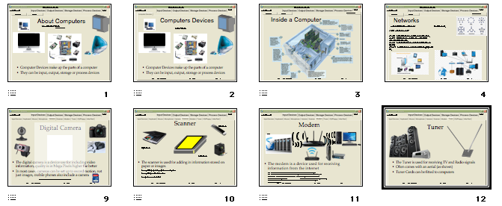
3.
- Name bottom (Centre), Date (bottom left hand corner) and the slide number (bottom left

hand corner) on each slide. 2
- Each slide (except the first and last slides) has a heading/title. 1
(2 + 1 = 3)
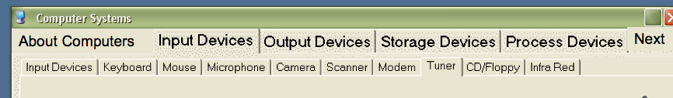
4.
- Text imported correctly 4
- Text arranged in logical format over all slides 2
- Slides not overcrowded 1
- Points in bullet format 1
- Font easy to read (size and choice of font) 1
- Consistent heading and body text styles 1
(4 + 2 + 1 + 1 + 1 + 1 = 10)

5. The presentation begins with a sound/music file being played. (1)

6.
- Background beige with or without gradient fill 5
- Font black (except headings) 1
(1 + 1 = 2)

7. Transition effect applied to each slide. (1)

8.
- Slideshow controlled with mouse click, including bullet points 2
- Points previously revealed are dimmed. 1
(2 + 1 = 3)

9. Graphics / clipart added to slides (60)

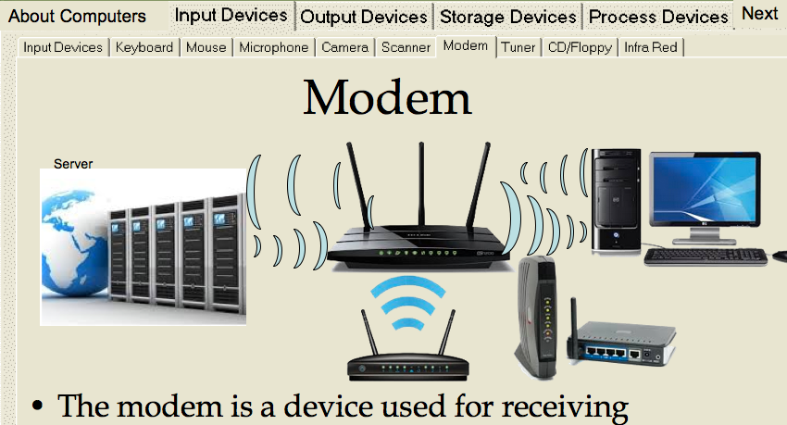
Text to use
Hardware
here is the computer and its associated equipment

Types of computer
The Processor - the centre of activity
CPU - central processing unit
The CPU includes
Control Unit
directs the system
Arithmetic/ Logic Unit (ALU)
arithmetic and logic operations

The processor types
CRT (cathode ray Tube) desktop computers
LCD (Liquid Crystal Display) laptops
TFT (thin film transistor) iPad

Input Devices
Keyboard - PC users, data entry
Mouse - used in graphical user interface (GUI) e.g Mac, Windows
MICR - Magnetic Ink Character Recognition, Used in cheque processing
OMR - Optical Mark Recognition,used in mult-choice tests, lotto, TAB
OCR - Optical Character Recognition,sales tags, desktop scanners
Wand Reader - libraries, stores, petrol stations
Bar Code Reader - store scanners
Light pens
Joysticks
Touch Screens
Digital Cameras
Voice

Output Devices
Monitors
Printers
Printers - Impact
daisy wheel
dot matrix
line printers
Printers - Non - Impact
ink-jet/bubble jet
plotter (CAD)
laser printer

Voice, music
Microfilm
Digital (USB)

Storage - Memory - Primary
RAM - Random Access Memory
holds instructions & data
data is lost when power off
ROM - Read Only Memory
contents cn be read and used but not replaced

Storage - Secondary
Magnetic or Optical
Permanent storage
Portable
Magnetic
Tape
Floppy Disk
Hard Disk
Flash memory
Removable hard drives
Optical - Write-Once Read-Many (WORM)
CD-Rom - compact disk read only memory
Laser discs

Marks as required (40)

Total 100

Need help just ask

